Hardware bitácora

In this document I will put any important research, information, decisions, about the hardware, component selection.

# MCU selection

This project will need a cortex-M4, because will use an LCD TFT 7” screen for control and mode selection, will use basic graphics, a telecommunication module, multiple sensors, an actuator, battery management, will have an internet connectivity, buttons, indicators leds.

One of the main characteristics is the memory, and communication protocol to use the LCD screen, so, I will need to choose also a development board to make the POC, and write over the HAL, because first I need to prove all the functions and the firmware to improve it.

The development boar to choose is [STM32F429I-DISC](https://www.mouser.mx/ProductDetail/STMicroelectronics/STM32F429I-DISC1?qs=79dOc3%2F91%2Fed3%252BRc5JUCEw%3D%3D&mgh=1&vip=1&gad_source=4) the board have a lcd integrate to prove the firmware and will be good for POC.

## STM32F429I

This board has the following characteristics

**General**

- Architecture: ARM Cortex-M4

- Maximum frequency: 180 MHz

- Flash memory: 2 MB

- SRAM: 256 KB

- EEPROM: Not integrated

- Operating voltage: 1.7V - 3.6V

- Power consumption: ~80-150 mA

**Processing and graphics**

- FPU (Floating Point Unit): Yes, supports floating point operations

- Graphics accelerator: Chrom-ART Accelerator™ (DMA2D)

- LCD interface: LTDC (for TFT displays up to 1024x768)

- External memory controller: FMC (for SDRAM, NOR, NAND, SRAM, etc.)

**Peripherals**

- Timers/PWM: 14 advanced and general timers

- ADC: 3x 12-bit ADCs, up to 24 channels

- DACs: 2x 12-bit channels

- GPIOs: 114 general purpose pins

- DMA: 16 DMA channels

**Communication interfaces**

- USART/UART: 8 (up to 12 Mbit/s)

- I2C: 3

- SPI: 6

- CAN: 2 (CAN 2.0B)

- USB: USB 2.0 OTG FS and HS (with external PHY for HS)

- Ethernet: Yes (MAC with IEEE 1588 support, external PHY required)

- SDIO: Yes, SD/MMC compatible

**Security**

- Watchdog (IWDG and WWDG)

- CRC (Cyclic Redundancy Check)

- Hardware Protected Memory (MPU)

Ideal applications

- Embedded systems with basic UI

- Devices with medium-sized TFT display

- Applications with Ethernet or USB connectivity

- Motor and sensor control

## STM32H723ZG

Main characteristics

**General**

Architecture: ARM Cortex-M7

Maximum frequency: 550 MHz

Flash memory: 2 MB

SRAM: 1 MB

EEPROM: Not integrate

Operating voltage: 1.62V - 3.6V

Power consumption: ~180-250 m

**Processing and graphics**

FPU (Floating Point Unit): Yes, supports floating point operations (single and double precision)

Graphics accelerator: DMA2D (for fast graphics handling)

LCD interface: LTDC + MIPI DSI (for high resolution TFT displays)

External memory controller: FMC (supports SDRAM, NOR, NAND, SRAM, etc.)

**Peripherals**

Timers/PWM: 32 advanced and general timers

ADC: 3x 16-bit ADCs, up to 36 channels

DACs: 2x 12-bit channels

GPIOs: 168 general purpose pins

DMA: 18 DMA channels

**Communication interfaces**

USART/UART: 8 (up to 20 Mbit/s)

I2C: 4

SPI: 6

CAN: 2 (CAN FD 2.0B, better than the standard CAN of the F429ZI)

USB: USB 2.0 OTG FS and HS with integrated PHY for HS

Ethernet: Yes (MAC with IEEE 1588 support, requires external PHY)

SDIO: Yes, SD/MMC compatible

**Security**

Watchdog (IWDG and WWDG)

CRC (Cyclic Redundancy Check)

Hardware Protected Memory (MPU)

Hardware encryption (AES, HASH, TRNG)

**Ideal applications**

Embedded systems with advanced UI and complex graphics

Intensive real-time data processing

Industrial and automation applications with CAN F

Telecommunication and networking systems (Ethernet, USB HS)

Advanced motor control with multiple sensors

## Resume

For this application I’m going to use the [STM32F49ZI](https://www.mouser.mx/ProductDetail/STMicroelectronics/STM32F429ZIT6?qs=DqCdCwOw4%2F5LWpMGYjTR8w%3D%3D) because this is the best fit for the project, the price is not the best per unit, something like 22 dollars, but for the project implications will need the power of processing, also will need to design the graphics and use linux, to run the program.

The expensive components will be the battery, the MCU and the screen, so, this design will need to get another iteration to get a lower price.

# Telecommunication module

The other critical component is the telecommunication module and the telecommunication protocol, where the data will be transmitter.

## Protocol

The selection of the way and where the data will be transmitted is a very important decision, because is the way how we will able to transmit the data in the rural environment, the project is for a rural implementations, normally will be deploy in the middle of the ranchs, farms, or in the middle of the field, for that reason is necessary secure a valid way to transmit the data.

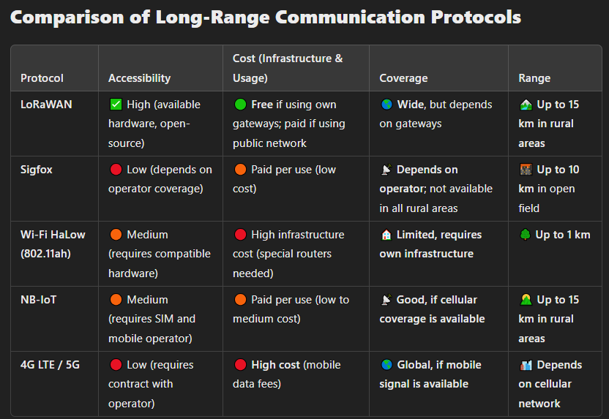

### LoRaWAN

LoRaWAN transmits information in the radio band, depending on the region 915 MHz in America and 868 MHz in Europe.

The basic architecture of the LoRaWAN system is:

1. LoRa Node (Module LoRa): Send data to the gateway using LoRa Modulation
2. Gateway LoRaWAN: receive data and send to the internet through Wi-Fi or ethernet.
3. Network server: filtering and processing the data, managing multiple gateway and safety.
4. Application Server: Manage the user data, let the visualization in a web or dashboard.

The communication protocol who needs LoRa is normally SPI or UART, the MCU have enough ports.

LoRaWAN modules:  
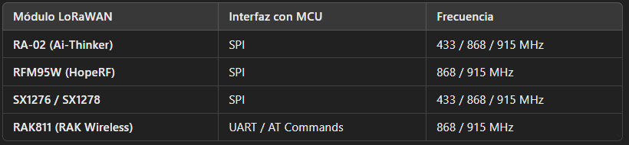

### Module Selection

[RFM95W (HopeRF)](https://cdn.sparkfun.com/assets/learn_tutorials/8/0/4/RFM95_96_97_98W.pdf)

**Pros:**  
✔️ Widely used in IoT and LoRaWAN projects.  
✔️ Compatible with libraries like **Arduino LoRa** and **LoRaMAC-node**.  
✔️ Easy integration with STM32 via **SPI**.  
✔️ Available in commercial modules for prototyping.

**Cons:**  
✖ Does not include a built-in LoRaWAN stack (requires additional software).  
✖ No UART interface for easy communication with MCU.

**📌 Specifications:**

* **Frequency:** 868/915 MHz (depending on region).
* **Interface:** SPI.
* **Transmission Power:** +20 dBm.
* **Sensitivity:** -148 dBm.
* **Voltage:** 1.8V - 3.7V.
* **Range:** Up to **15 km in rural environments**.

**🔧 Commercial Prototyping Modules:**

* **Adafruit RFM95W LoRa Radio Bonnet** (for Raspberry Pi).
* **SparkFun RFM95W Breakout Board** (for STM32 integration).

[RA-02 (Ai-Thinker)](https://www.digikey.com.mx/en/products/detail/ai-thinker/RA-02/16688840)

**Pros:**  
✔️ **Very affordable** compared to other modules.  
✔️ Uses the same SX1278 chip (compatible with many libraries).  
✔️ Available in **shields and commercial modules**.  
✔️ Easy to use with **STM32 via SPI**.

**Cons:**  
✖ Requires an external antenna for optimal performance.  
✖ Does not include a built-in LoRaWAN stack (manual setup required).

**📌 Specifications:**

* **Frequency:** 433/868/915 MHz.
* **Interface:** SPI.
* **Transmission Power:** +18 dBm.
* **Sensitivity:** -139 dBm.
* **Voltage:** 3.3V.
* **Range:** Up to **10 km in open environments**.

**🔧 Commercial Prototyping Modules:**

* **Ai-Thinker RA-02 Breakout Board** (compatible with STM32).
* **TTGO LoRa Module (with ESP32 + RA-02 integrated)**.

[**RAK3172**](https://store.rakwireless.com/products/wisduo-lpwan-module-rak3172)

**Pros (Advantages)**

1. **Integrated MCU (STM32WLE5CCU6)**
   * Runs its own firmware, eliminating the need for an external MCU in some cases.
2. **Low Power Consumption**
   * Deep sleep: **1.69 µA**, making it ideal for battery-powered applications.
3. **High RF Sensitivity & Power**
   * TX Power: **Up to +22 dBm**
   * RX Sensitivity: **-148 dBm**
   * Ensures **long-range communication** in rural environments.
4. **Supports LoRaWAN & LoRa P2P**
   * Can work in **LoRaWAN networks** or in **direct point-to-point (P2P) mode**.
5. **Multiple Interfaces**
   * **UART, SPI, I2C, GPIO, ADC, PWM**
   * Offers flexibility for sensor and actuator integration.
6. **STM32 Ecosystem Compatibility**
   * Can be programmed using **STM32CubeIDE**.
   * Uses **AT commands** for quick prototyping via UART.
7. **Certified for Global Use**
   * FCC, CE, TELEC certifications simplify compliance in different markets.
8. **Prototyping & Breakout Boards Available**
   * **RAK3172 Breakout Board** for easy testing.
   * **WisDuo RAK3172-E Evaluation Board** with USB-to-serial interface for quick development.

**Cons (Disadvantages)**

1. **Limited Memory**
   * **64KB RAM / 256KB Flash**, which may be insufficient for complex applications.
2. **No Native Ethernet or Wi-Fi**
   * Requires an external module to send data directly to the internet.
3. **Single LoRa Radio**
   * Cannot operate on **multiple frequencies simultaneously**.
4. **Programming Complexity**
   * **STM32CubeIDE required** for custom firmware, which has a learning curve.
5. **External Antenna Required**
   * Needs a **U.FL connector antenna**, adding cost & assembly steps.